***BitBeat: Music Generator Proposal for Generative Art Hackathon***

PROBLEM

Music is an art form which organizes sounds, rhythms and melodies in time. The creation, performance, significance of music can vary according to different cultures and social contexts.

Music also connects people all over the world and brings people together. So apparently there is no way an artificial being such as a computer could possibly compete with this.

THE HACKATHON PROJECT

Our goal is to create something that would make the listeners believe they are listening to a musical piece created by a human.

In order to reach our goal we will exploit RNNs (recurrent neural networks). RNNs are a type of artificial neural network designed to recognize patterns in sequences of data, such as text, genomes, handwriting, or numerical time series. Research shows them to be one of the most powerful and useful type of neural network applicable to large datasets.

Specifically we will use LSTMs (long-short term memory network): they are a type of recurrent neural network that can efficiently learn, recognize and encode long-term patterns using a gating mechanism. LSTMs are extremely useful to solve problems where the network has to remember information for a long period of time as in music and text generation.

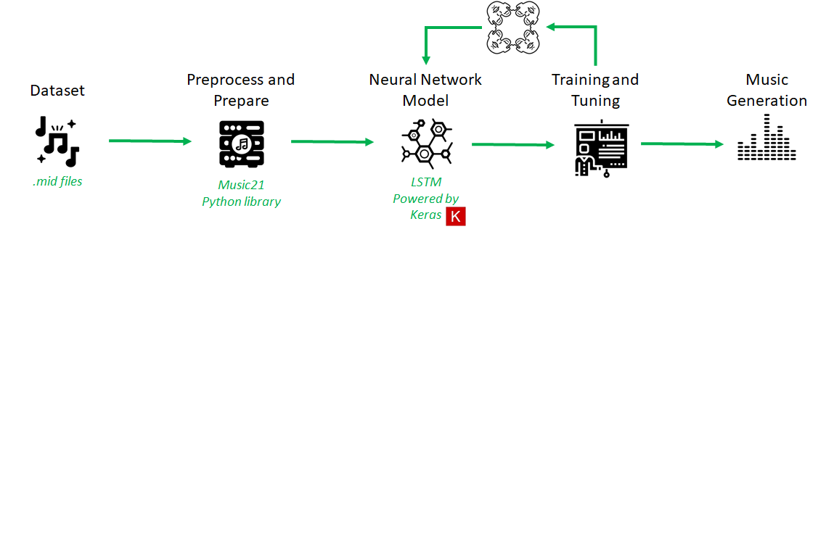

We would also like to show that the generated music varies based on the type of musical dataset it receives. For example, if the LSTM is trained on classical piano pieces we expect the network to generate classical melodies with many notes played without those patterns which characterize modern pop music.

On the other hand, if the LSTM is trained with looping melodies, we expect the network to generate repetitive patterns throughout the melody.